

**Patient Experience (including Complaints) Annual Report 2023/24**

**Experience Strategy Update**

In May 2023, the trust published a three year strategy for patient engagement and experience – Patient Engagement and Experience Strategy (PEES) 2023-2026. The strategy had four objectives:

* **Strategic Objective One:** Involvement—“To promote the role and benefits of the public and patients shaping our services, and to develop new and innovative ways of working with you”
* **Strategic Objective Two:** Create opportunities for feedback, Ensure we have appropriate mechanisms for capturing this feedback, Listening to what our patients are sayings and Acting on it - *“To improve how we share the improvements made after your feedback and the patient involvement work we do”*
* **Strategic Objective Three:** Creating a culture – *“Moving patient experience to the spotlight”*
* **Strategic Objective Four: Accessibility and Partnerships –** “To develop our partnerships and increase the number and diversity of people involved, creating accessibility for all”

The Patient and Public Experience and Engagement Group (PPEEG) is established as a sub-committee of the Quality Committee, a formal committee of the Trust Board. The PPEEG provides strategic vision and oversight of all areas patient experience, and leads, promotes and informs the patient experience agenda and strategy at the Trust. The group receives bi-annual reports from Divisions and sub-groups, such as volunteers, research, chaplaincy, learning disability, to monitor their patient experience programmes of work and ensure progress against the PEES and the Trust quality priorities. The group is chaired by the Director of Nursing for Chelsea and Westminster Hospital.

Considerable progress against these objectives has been achieved over the course of the year, with regards to both the aspirational quanitiative metrics but also some of the more cultural shifts and external engagement. Year one progress against the strategy is outlined through pages 5-13 using the RAG index below:

|  |  |
| --- | --- |
| **Status (RAG)** | |
| Complete |  |
| On track or Ongoing |  |
| Delayed |  |
| At risk |  |

See below some of the key achievements for 2023-24 year:

* Regular engagement and interactions with Healthwatch partners for projects/representatives, within the Hounslow Borough Based Partnership (BBP) for collaborative working across the borough and with local community groups, such as Action Disability Kensington and Chelsea (ADKC), Ilays (East African Community), NWL BME Health Forum and the Hounslow Muslim community group for PLACE assessments and other activities.
* Despite aiming to move away for response rate % for 24-25 year, the trust did achieve the aspiration of a 15% response rate for 23-24, which was 5% higher than the national average and suggests we offer a lot of patients opportunities for feedback
* Qualitative patient experience data, such as patient stories, CareOpinion messages and ward accreditation data have been used to help services get deeper insights into the experiences of patients in their areas

A considerable effort has been put into supporting services and divisions with interpreting their national CQC survey data, as the Maternity, Inpatient, UEC, Cancer and Stroke survey results have all been made available over the last year, and developing individual action plans in collaboration with patients where possible. It is hoped in upcoming surveys, the improvements initiaited by services in response to these results will be seen.

Despite the successes noted above, there have been a number of challenges or limited progress with some of the objectives and patient experience workstreams. These have been outlined below and will form part of the 2024-25 team priorities:

* It was hoped that there would be a central system that would host all patient experience/feedback data across complaints, PALS, FFT, local surveys, engagement events and ward accreditation; this in turn would allow for deeper and more valuable user insights to be used as part of any improvement initiatives. Unfortunately this has not happened meaning the triangulation of feedback data from these sources is manual and resource heavy.
* The patient involvement charter, which gives the trust a standardised approach to user involvement, was coproduced with patients and public between June – December 2023. This charter was approved in principle by senior nursing cabinet in January 2024 however the charter cannot be implemented until the remuneration process is clarified. This is ongoing.
* Whilst patient stories have started to be gathered and shared in certain meetings and groups, there needs to be greater integration of patient stories within services and across the trust to influence change and improve patient experience.
* The FFT dashboard does not support easy analysis of demographic data, meaning it can be resource heavy to fully review this type of information to help identify any inequalities in experience.
* Continued work to improve the complaints process to make this meaningful and helpful for our patients, including responses in plain English and that outcomes are clearly explained.

**PALS and Complaints**

The PALS and Complaints team manage the formal complaints process on behalf of the Trust and will facilitiate an investigation, providing a timely response that addresses the complaint and highlighting any learning. We aim to respond to 95% complaints within 25 working days, or by an agreed timeframe.

PALS and Complaints data for the year 2023/4 is at Appendix 1 of the report. Highlights include increased activity by the team across all areas of the service with 4569 contacts in the past year.

It has been highlighted that the service receiving the most complaints for 23/24 is the Maternity Assessment Suite at Chelsea and Westminster Hospital.

Themes of complaints continue to be similar to previous years, in respect of communication, patient care and clinical treatment. We have also seen an uptick in the number of complaints about the values and behaviours of our staff, but these numbers remain low.

Examples of learning from complaints are contained within the main report.

The PHSO have taken on six complaints for investigation over the past year and there is a complaint ongoing which they began to investigate during the previous year.

The team’s focus for the year ahead is to recover the position with compliance with the complaints KPI so that we meet this every month. It is also noted that compliance has not been met for the past two months with responding to PALS concerns within five working days – this has been attributed to staffing changes in the team and the position will recover during April 2024.

**Strategic Objective One:** Involvement—“To promote the role and benefits of the public and patients shaping our services, and to develop new and innovative ways of working with you”

|  |  |  |  |  |  |
| --- | --- | --- | --- | --- | --- |
| **Objective 1 - 2023-24 Forward Plan Actions** | | | | | |
| **What did we say we would do?** | **RAG** | **Q1, Q2 & Q3 activities** | **Q4 – what have we done?** | **Impact** | **Recommendations or risks** |
| Review Patient and Public Engagement and Experience Group (PPEEG) Terms of Reference (ToR) and purpose |  | PPEEG agenda adapted based on group feedback to include patient stories, patient involvement, patient leaflets and you said we did | Meeting occurring monthly and quorate | Patient stories have given a deeper insight into the quantitative metrics shared during the meeting  Patient involvement as an agenda item has helped divisions demonstrate outcomes of effective engagement and started to positively impact culture of the organisation with to how we consider involving patient in projects | Annual review of PPEEG ToR and effectiveness |
| Create a process for user involvement |  | Patient involvement charter developed, with feedback and involvement from patients and staff. Charter approved by senior nursing cabinet and PPEEG | Explore and agree the remuneration process of patient involvement | To be determined once charter has been approved | 24-25 focus will be to agree remuneration process and pilot this charter over the year  **Risk –** without a standardised approach, the trust will continue to have inconsistencies in involving patients and reporting on involvement activities. The lack of a clear remuneration over involvement will continue to act as a barrier to some more diverse groups getting involved in trust improvement work |
| **Other Activities** | | | | | |
| **What did we say we would do?** | **RAG** | **Q1, Q2 & Q3 activities** | **Q4 – what have we done?** | **Impact** | **Recommendations or risks** |
| Get more involved with local partners, communities and residents |  | Ad-hoc and regular engagement activities across both hospital sites with health and social care partners, local community groups and patient representatives.  Support services in setting up local patient forums, such as Hand Therapy and Endoscopy.  National Patient Led Assessments of the Care Environment (PLACE) undertaken in October 2023. 20+ patient representatives supported across both sites.  Continue to support services with local engagement initiatives.  More collaborative working with Communications team to triangulation engagement work across the boroughs. | Continued to engage regularly with external stakeholders and partners.  Example activities:   * Isleworth Health roadshow * Hounslow Borough Based Partnership (BBP) in February and March – the latter date was to discuss the trust’s strategy and priorities, and ascertain patient and public feedback on these * Women’s health event hosted in the trust on 9th March * Community based women’s health event 16th March * Youth forum restart. Good engagement at West Middlesex with 5 young people attending the first forum in February, sharing ideas on improving care * PLACElite assessments in February cross site. Good representation for external partners. * External survey to residents asking for feedback on trust strategy and priorities * Ambulatory Diagnostic Centre engagement event, listening to resident feedback in March | Increase quality of care provided in certain areas and identify new ways of working or other improvements to the hospital services | Continue to build on current relationships and identify new potential partners  Continue to capture and report on engagement activity and the subsequent impact of this  **Risks -** The Trust does not have a dedicated resource for patient involvement and it is currently integrated into the roles of patient experience and communications team. The associated risk is that without the dedicated resource, the quality and effectiveness of involvement will be limited. |
| One patient led project by end of 2023-24 |  | Trust specific aspects of the project have been completed – surveying of staff, patient and carer experience for patients with learning disabilities. Results shared with LD lead nurse and wider clinical colleagues for learning. | Ongoing discussions on how to use these survey results more widely across the health and social care sector within NWL | Local learning for the Trust identified | Trust LD team, commissioner and other health & social care and local authority partners to meet and discuss a way forward |

**Strategic Objective Two:** Create opportunities for feedback, Ensure we have appropriate mechanisms for capturing this feedback, Listening to what our patients are sayings and Acting on it - *“To improve how we share the improvements made after your feedback and the patient involvement work we do”*

|  |  |  |  |  |  |
| --- | --- | --- | --- | --- | --- |
| **Objective 2 - 2023-24 Forward Plan Actions** | | | | | |
| **What did we say we would do?** | **RAG** | **Q1, Q2 & Q3 activities** | **Q4 – what have we done?** | **Impact** | **Recommendations or risks** |
| Introduction of a complaints satisfaction survey |  | Survey developed in Q2 and distributed to all complainants | Continued to send survey link to complainants when they receive their response | Positives:   * Complainants feel process is accessible and easy to understand * Complainants don’t feel the process impacts their care   Improvements:   * Review how we maintain communication with people raising complaints throughout the process * Need to ensure learning outcomes are clearer * Review the clarity in responses to ensure they are in plain English | Limited responses from Q2-Q4 (n-13)  **Risk –** we don’t know if the complaints process is user friendly, accessible or satisfactory  Head of Complaints to review feedback and on a reinvigorated approach to understanding experience of complaints process with the complainants |
| Creation of a ‘Patient Story’ framework |  | Patient story guidance document developed and approved at May’s PPEEG. First patient story brought to June’s PPEEG (planned care)  Patient stories from David Evans, NICU and Endoscopy discussed at PPEEG and a number of associated actions have been implemented at a service level or are being considered by the Trust.  EIC included a patient story in their recent staff away day | Patient stories continue to see traction both within the framework of PPEEG but wider afield:   * Serious incident patient story shared at PPEEG in March * Patient stories included in newly developed customer service training, which is being piloted with patient access colleagues * Regular sharing of patient stories within maternity experience meetings | Patient story guidance has supported divisions with integrating stories into their practices  100% (n-50) of staff spoken to stated that patient stories have helped gain a deeper understanding of experiences and where they can improve; however 23-24 ward accreditation results show that a high % of all areas are unsure how to approach patient stories in their areas | Continue to promote and encourage the use of patient stories  Look to do a campaign week with staff to educate them on patient stories, the approach and how they can be integrated into working practices  Look at developing an impact framework for areas that are using patient stories  Build a repository of stories (written, audio, video) to be used with service redesign, evaluation, meetings or for sharing lived experiences with other patients |
| **Other Activities** | | | | | |
| **What did we say we would do?** | **RAG** | **Q1, Q2 & Q3 activities** | **Q4 – what have we done?** | **Impact** | **Recommendations or risks** |
| Ensure data and themes from feedback are being actioned regularly |  | Training, education and awareness sessions completed with staff of different roles/grades on patient feedback  Feedback Friday – Quality Round where all nursing leaders completed a patient experience survey with patients in their area and a staff survey to identify the culture for patient feedback | Continued awareness sessions with staff, when needed, on a weekly basis based on key feedback themes per area | Q4 satisfaction rate 88% and response rate 15% (1% and 2 % improvement vs Q3) | **Risk –** currently there is a culture in some departments that FFT satisfaction and response rates are viewed as quantifiable targets as opposed to qualitative insights. For 24-25 and onwards, we need to support services with understanding their insight data more and how it can be used to influence change |
| Ensure the Trust is responsive to patient feedback on public domain platforms |  | Internal process developed within the patient experience team for reviewing, responding and disseminating public domain feedback to divisions. Public domain feedback continues to be shared | As of January 2024, NHSE restrictions have prevented trusts from responding to google review feedback. CareOpinion feedback continues to be shared where relevant with divisions. | Triangulation with other feedback data has helped identify where key priorities need to be e.g A&E at West Middlesex, Maternity | Continue to share as normal and support services with understanding the insights of this data |
| Act on national patient survey results |  | In Q1-Q3 the trust was in receipt of the following:   * National cancer 2022 survey results * National stroke 2022 survey results * National inpatient 2022 survey results * National UEC 2022 survey results * Internal maternity 2023 results   Action planning support provided to divisions to understanding the survey insights and areas for improvements | CQC published the national benchmarking report for the maternity 2023 survey. Results shared with trust and used for improvement action planning  UEC and Maternity patient accessing care in Q4 could be selected to take part in the 2024 survey iterations | National survey results, triangulated with other feedback, has helped support improvement initiatives and prioritise areas of focus for patient experience within divisions or areas | Continue to ensure the Trust takes part in the national survey programme, share results with divisional/service leads and support with action planning using the other patient experience data |

**Strategic Objective Three:** Creating a culture – *“Moving patient experience to the spotlight”*

|  |  |  |  |  |  |
| --- | --- | --- | --- | --- | --- |
| **Objective 3 - 2023-24 Forward Plan Actions** | | | | | |
| **What did we say we would do?** | **RAG** | **Q1, Q2 & Q3 activities** | **Q4 – what have we done?** | **Impact** | **Recommendations or risks** |
| Development, implement and integration of a Patient Experience Accreditation |  | Patient experience has been integrated into the trust ward accreditation tool and the location specific questions have helped elicit greater insights into experiences of patients.  A total of 32 areas have been assessed as part of the ward accreditation programme in Q1 and Q2 and the results have helped support improvement initiatives around noise at night, protected meal times and a welcome pack.  24 locations accredited in Q3, which were predominantly outpatient areas | All remaining ward accreditations undertaken (n-53), including outpatients, sexual health, imaging, maternity and medical photography | The patient experience questions and results continue to provide services with insights into patient experience; assurance on what is working well and areas for improvements. | Currentlythere is no central visibility of all the patient experience data collected from ward accreditation, in order for this to be triangulated with other experience data. The risk is that potential patient experience improvements will be ineffective as it only gives a small snapshot in time  24-25 focus will be to create a central hub/dashboard for ward accreditation patient experience data |
| **Other Activities** | | | | | |
| **What did we say we would do?** | **RAG** | **Q1, Q2 & Q3 activities** | **Q4 – what have we done?** | **Impact** | **Recommendations or risks** |
| Identifying and upskilling of patient experience ‘champions’ across the Trust |  | ‘Champions’ identified informally in certain areas and promoting patient experience and feedback. These champions have taken a proactive role in survey meetings and other patient experience projects.  Examples have included:   * Introduction of an EASYREAD Friends and Family Test form for elderly care wards * Monthly outpatient meetings to discuss feedback themes and improvement initiatives | Continued engagement with key staff across the Trust. | Ensuring that patient experience is a continued topic of discussion amongst staff in these areas and helped ensure there are more proactive processes for acting on feedback | Continued engagement with key staff across the Trust |
| Redesign patient experience intranet pages and develop a patient experience toolkit to help educate and empower staff |  | Page experience pages updated | No further action required | Refreshed patient experience pages have received positive feedback from staff | Continue to evaluate effectiveness of staff resources and information on patient experience pages |

**Strategic Objective Four: Accessibility and Partnerships –** “To develop our partnerships and increase the number and diversity of people involved, creating accessibility for all”

|  |  |  |  |  |  |
| --- | --- | --- | --- | --- | --- |
| **Objective 4 - 2023-24 Forward Plan Actions** | | | | | |
| **What did we say we would do?** | **RAG** | **Q1, Q2 & Q3 activities** | **Q4 – what have we done?** | **Impact** | **Recommendations or risks** |
| To review 22-23 patient demographic report to highlight good practice and identify scope for improvement work |  | Inclusion of patient demography questions on the ward accreditation tool has helped drive the need for greater data quality patient demographics  BI / data warehouse team have joined the NWL WSIC system which has allowed for integration of primary care data with trust data | No progress | Improvements in capturing of ethnicity, language and religion data. | Compliance percentages for some protected characteristics has improved with the merge of WSIC however there are still a number of gaps or low percentages i.e. religion, sexual orientation, disability etc  **Risk –** we don’t know our patients and cannot adequately support them  As a trust we need to review current processes for capturing and validating this data and agree a process going forward |

**Friends and Family Test (FFT) – Trust**

The Friends and Family Test (FFT) is an important feedback tool that supports the fundamental principle that people who use NHS services should have the opportunity to provide feedback on their experience. Listening to the views of patients and staff helps identify what is working well, what can be improved and how. The FFT asks people to rate their experience and give a commentary to support their rating.

For 2023-24 period, the Trust’s average positive rating was 88%, which was a 1% improvement from 2022-23. However the biggest improvements were seen in the response rate and response totals; the trust saw a 6% improvement in the response rate which was an additional 35102 (43.16% increase). When comparing sites, Chelsea and Westminster Hospital have an overall reported satisfaction score of 89% from 57,000 responses, whilst West Middlesex University Hospital have an overall reported satisfaction score of 87% from 42,000 responses.

Figure 1: Trust-wide FFT satisfaction % since 1st August 2022

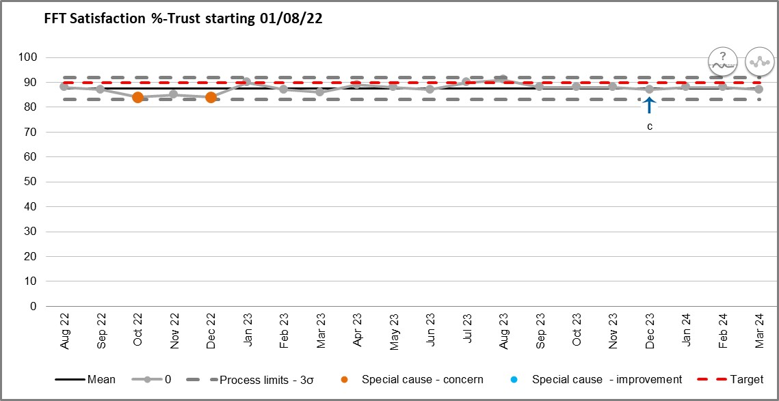

Figure 2: Trust-wide FFT response rate % since 1st August 2022

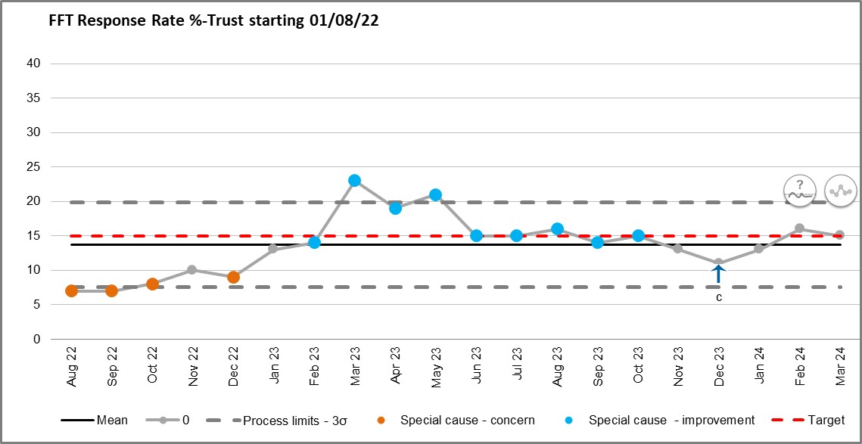

In April 2015, NHSE removed the national requirements related to response rates to discourage the disproportionate focus on achieving very high response rates, which led to providers thinking about FFT as a tick-box exercise. Commissioners will want to see that a reasonable amount of feedback is being collect, but what is reasonable will vary from setting to setting. Organisations are expected to ensure opportunities are in place for patients to give feedback but more importantly, services are using this feedback to identify good practice and opportunities to improve. Therefore, in the next section of the report and in future quarterly/annual reports, total number of FFT responses will be highlighted as opposed to response rate as a percentage. Also, CWFT satisfaction rate will be benchmarked against the aggregated NWL and national satisfaction scores.

**Friends and Family Test (FFT) – North West London Acute Collaborative and National 2023-24 Comparison**

Accident & Emergency

Figure 3: A&E FFT satisfaction % comparison CWFT, NWL and National

Figure 4: A&E FFT total responses comparison CWFT, NWL and National

|  |  |  |  |  |  |  |  |  |  |  |  |  |
| --- | --- | --- | --- | --- | --- | --- | --- | --- | --- | --- | --- | --- |
| A&E Total number of response | | | | | | | | | | | | |
|  | Apr-23 | May-23 | Jun-23 | Jul-23 | Aug-23 | Sep-23 | Oct-23 | Nov-23 | Dec-23 | Jan-24 | Feb-24 | Mar-24 |
| CWFT | 3433 | 3989 | 3887 | 3879 | 3506 | 3860 | 4696 | 3666 | 3851 | 4878 | 4937 | 4976 |
| LNW | 1533 | 1627 | 1607 | 1888 | 1082 | 1956 | 5390 | 4699 | 3076 | 3665 | 6228 | 5082 |
| ICH | 1183 | 1268 | 1105 | 1287 | 1194 | 1147 | 1134 | 1266 | 1266 | 1471 | 1123 | 1130 |
| THH | 778 | 778 | 776 | 741 | 753 | 815 | 1057 | 607 | 822 | 845 | 870 | 837 |

The reported patient experience in A&E for CWFT has exceeded the national average and compares favourably and in line with the NWL satisfaction rate. As a trust, CWFT offers more patients opportunities to provide feedback on their A&E experience through the survey compared to other trusts within the NWL Acute Provider Collaborative (APC), accounting for an average of 46% of all NWL responses since April 2023.

When comparing sites, Chelsea and Westminster Hospital A&E departments had approxiametely 31000 responses across the year with an overall 85% satisfaction rate; however the A&E departments at West Middlesex University Hospital received 19000 responses (11k less than CW) with a 77% overall satisfaction rate (8% less than CW).

Key themes for improvements from A&E FFT survey mirror those seen in the national surveys and complaints/PALS data – waiting times and environment, communication regarding condition and diagnosis, and general staff interactions; a much larger proportion of the negative feedback relates to the A&E at West Middlesex University Hospital. The number of positive responses regarding compassionate care and basic care provision outweigh the number of negative responses in this regard.

A&E departments at both sites have used their FFT data, in conjunction with other patient feedback intelligence, to improve the waiting environment which includes regular refreshment rounds, new layout of seating creating more space, electronic waiting boards to keep patients updated of wait times. The team have also started to review patient information available in the department and how they communicate better with patients around their condition, tests and what happens once they leave the department.

Inpatient

Figure 5: Inpatient FFT satisfaction % comparison CWFT, NWL and National

Figure 6: Inpatient FFT total responses comparison CWFT, NWL and National

|  |  |  |  |  |  |  |  |  |  |  |  |  |
| --- | --- | --- | --- | --- | --- | --- | --- | --- | --- | --- | --- | --- |
| Inpatient Response Totals | | | | | | | | | | | | |
|  | Apr-23 | May-23 | Jun-23 | Jul-23 | Aug-23 | Sep-23 | Oct-23 | Nov-23 | Dec-23 | Jan-24 | Feb-24 | Mar-24 |
| CWFT | 1082 | 1210 | 1052 | 1083 | 1304 | 1135 | 1035 | 808 | 709 | 975 | 853 | 685 |
| LNW | 1501 | 1933 | 1686 | 2084 | 1639 | 944 | 2806 | 2637 | 2197 | 3060 | 2476 | 3157 |
| ICH | 2126 | 2477 | 2194 | 2402 | 2592 | 2504 | 2544 | 2614 | 2004 | 2746 | 2856 | 2793 |
| THH | 1209 | 1486 | 1579 | 1320 | 1395 | 1181 | 807 | 495 | 1103 | 871 | 1571 | 1492 |

The reported experience of our admitted patients is consistently higher than the national average and in line with other trusts across the NWL ACP according to the FFT. However, a big risk is associated with the inpatient FFT survey results is that CWFT make up on average 15% of the total response numbers across NWL and does not give a true and accurate reflection of the care being provided to our patients, as seen in the more detailed national CQC inpatient survey results. Also, whilst there are marginal differences in overall reported satisfaction scores between the sites; Chelsea and Westminster Hospital 94% compared to West Middlesex University Hospital 96%, the latter has received approximately 2000 more responses over the year.

**Action:** There needs to be a concerted effort to improve responses to the inpatient FFT survey specifically at the Chelsea and Westminster Hospital site, which in turn will enable a more representative view of inpatient experience. There are plans to include additional supplementary questions to the standard FFT form for inpatient areas, to hopefully elicit richer feedback and allow for ongoing assurance.

The total number of responses linking with positive themes of the survey outweight the same themes in a negative way.

The Trust adopted the Magnet Shared Decision making model in late 2022, and the FFT data has been pivotal in identifying key areas of improvements for wards and support initiatives taken through this model. Examples of initiatives include noise cancelling speakers to improve the night environment, improved access to entertainment or projects focused on reducing deconditioning.

Maternity (antenatal)

Figure 7: Maternity (antenatal) FFT satisfaction % comparison CWFT, NWL and National

Figure 8: Maternity (antenatal) FFT total responses comparison CWFT, NWL and National

|  |  |  |  |  |  |  |  |  |  |  |  |  |
| --- | --- | --- | --- | --- | --- | --- | --- | --- | --- | --- | --- | --- |
| Antenatal Response Total | | | | | | | | | | | | |
|  | Apr-23 | May-23 | Jun-23 | Jul-23 | Aug-23 | Sep-23 | Oct-23 | Nov-23 | Dec-23 | Jan-24 | Feb-24 | Mar-24 |
| CWFT | 52 | 53 | 64 | 58 | 66 | 77 | 59 | 45 | 48 | 59 | 64 | 60 |
| LNW | 75 | 70 | 74 | 97 | 55 | 0 | 1 | 0 | 0 | 33 | 2 | 2 |
| ICH | 50 | 47 | 55 | 53 | 65 | 49 | 60 | 64 | 45 | 64 | 57 | 62 |
| THH | 109 | 107 | 104 | 101 | 118 | 96 | 98 | 27 | 1 | 1 | 37 | 72 |

CWFT have an equal share of responses to the antenatal FFT when compared across the NWL APC however the women accessing care at the trust report a worsening experience than those who access antenatal at the other NWL trusts.

Maternity (birth/labour)

Figure 9: Maternity (birth) FFT satisfaction % comparison CWFT, NWL and National

Figure 10: Maternity (birth) FFT total responses comparison CWFT, NWL and National

|  |  |  |  |  |  |  |  |  |  |  |  |  |
| --- | --- | --- | --- | --- | --- | --- | --- | --- | --- | --- | --- | --- |
| Birth Response Total | | | | | | | | | | | | |
|  | Apr-23 | May-23 | Jun-23 | Jul-23 | Aug-23 | Sep-23 | Oct-23 | Nov-23 | Dec-23 | Jan-24 | Feb-24 | Mar-24 |
| CWFT | 57 | 55 | 50 | 64 | 52 | 91 | 55 | 39 | 47 | 54 | 58 | 52 |
| LNW | 76 | 62 | 30 | 33 | 5 | 0 | 15 | 25 | 107 | 86 | 25 | 86 |
| ICH | 56 | 62 | 90 | 114 | 66 | 114 | 165 | 125 | 90 | 106 | 72 | 100 |
| THH | 38 | 49 | 36 | 42 | 30 | 40 | 31 | 25 | 76 | 27 | 23 | 32 |

Similar to antenatal FFT, CWFT receive an equal share of the total responses across NWL APC for completed labour and birth FFT surveys. Despite having volatile changes in women’s experiences of birth, CWFT remains one of the top performing trusts in London for this, which mirrors the national survey findings.

Maternity (postnatal ward)

Figure 11: Maternity (postnatal ward) FFT satisfaction % comparison CWFT, NWL and National

Figure 12: Maternity (postnatal ward) FFT total responses comparison CWFT, NWL and National

|  |  |  |  |  |  |  |  |  |  |  |  |  |
| --- | --- | --- | --- | --- | --- | --- | --- | --- | --- | --- | --- | --- |
| Postnatal Ward Response Total | | | | | | | | | | | | |
|  | Apr-23 | May-23 | Jun-23 | Jul-23 | Aug-23 | Sep-23 | Oct-23 | Nov-23 | Dec-23 | Jan-24 | Feb-24 | Mar-24 |
| CWFT | 222 | 256 | 244 | 234 | 254 | 237 | 296 | 141 | 147 | 133 | 137 | 100 |
| LNW | 97 | 143 | 311 | 158 | 125 | 96 | 171 | 160 | 105 | 155 | 51 | 96 |
| ICH | 31 | 41 | 67 | 121 | 156 | 114 | 143 | 124 | 64 | 73 | 49 | 91 |
| THH | 99 | 144 | 100 | 234 | 85 | 67 | 26 | 24 | 74 | 3 | 113 | 74 |

CWFT accounts for 40% of the total number of responses received for postnatal FFT across NWL. The trends in the data both nationally and across NWL see similar dips and peaks as at CWFT, however women accessing postnatal ward care at CWFT consistently report a worsening experience.

**Action:** A postnatal patient experience working group was set up in October 2023, meeting on a bi-monthly basis, to oversee feedback themes and ensure there are robust processes in place to listen and act on this.

Generally speaking the themes from the FFT surveys across maternity mirror those seen in the national surveys and other audits – information provision, communication around care, compassionate care, pain management, discharge issues and involvement in treatment decisions. FFT is regularly shared with maternity leads across both sites to ensure it is being acted on.

Improvements that have been initiated in response to patient feedback include increased antenatal appointment times to give women more opportunities to discuss their concerns with the team, review and revision of patient information for induction of labour, cue cards for staff to ensure they are asking about a woman’s mental health during appointments and a kindness campaign across the postnatal wards.

At the start of the 2024-25 year, the trust recruited new chairs of the Maternity and Neonatal Voices Partnership (MNVP) and this group will play a pivotal role in working with women on where our improvements should be focused but more importantly, codesigning and coproducing that improvement work.

Lastly, whilst there are marginal differences between both sites when looking at the overall FFT satisfaction score across the whole maternity journey, West Middlesex University Hospital typically scores lower for postnatal ward experience and the site as a whole has received approximately 1300 less survey responses from women accessing maternity care.

Outpatients

Figure 13: Outpatient FFT satisfaction % comparison CWFT, NWL and National

Figure 14: Outpatient FFT total responses comparison CWFT, NWL and National

|  |  |  |  |  |  |  |  |  |  |  |  |  |
| --- | --- | --- | --- | --- | --- | --- | --- | --- | --- | --- | --- | --- |
| Outpatient Response Totals | | | | | | | | | | | | |
|  | Apr-23 | May-23 | Jun-23 | Jul-23 | Aug-23 | Sep-23 | Oct-23 | Nov-23 | Dec-23 | Jan-24 | Feb-24 | Mar-24 |
| CWFT | 1586 | 1596 | 1844 | 2383 | 2596 | 2214 | 2398 | 2391 | 1734 | 2515 | 1897 | 1954 |
| LNW | 4192 | 5005 | 4714 | 4569 | 3208 | 541 | 722 | 5648 | 3903 | 5258 | 5090 | 4266 |
| ICH | 6941 | 7529 | 8304 | 8193 | 8454 | 7822 | 7880 | 9720 | 7284 | 9891 | 9155 | 4051 |
| THH | 2764 | 2810 | 3300 | 2866 | 2994 | 3064 | 2760 | 1937 | 2631 | 2626 | 3920 | 3968 |

Despite the Outpatient FFT positive score data indicating that we are one of the top 3 performing Trusts in London, context should be given as we are one of the worst performing Trusts for response totals across NWL ACP (making up only 12% of the total number of completed surveys). Continued efforts have been made with clinical leads to champion responses across their areas however there are challenges with certain administrative staff promoting this. There are no significant differences between both hospital site’s outpatient departments, with regards to overall satisfaction score and overall response totals.

**Action:** There needs to be a concerted effort and push to encourage more feedback from all outpatient areas to ensure we are getting a representative picture of outpatient experiences. The patient experience team will also review expenditure for 24-25 to determine if additional funds could be used within outpatient areas to improve response numbers, but this will be at the detriment to other area’s responses. An options paper will be submitted to the Executive team detailing options and ideas for this.

Scope for improvement based on the outpatient FFT survey results revolve around the themes of appointment issues (cancellations, rescheduling, incorrect timings etc) wait times once in the hospital, waiting environment and communication around treatment/diagnosis/tests. The Trauma & Orthopaedic department have introduced virtual boards in the waiting area and the Ophthalmology department have introduced music, both to improve waiting experiences for patients. New signage will be introduced across the Chelsea and Westminster Hospital site over the coming months and once in place, plans will be to replicate this at West Middlesex University Hospital whilst also looking at more patient friendly wayfinding and navigation systems. Outpatient appointment reminder text messaging has been introduced over the last 12-18 months which has helped improve Did Not Attend (DNA) rates. A Trust wide steering group has been set up, with patient involvement, looking at how we can better improve communication with our patients accessing outpatient care. Outcomes of this group will be noted in the 2024-25 patient experience annual report. The number of compliments received within the survey regarding compassionate care outweigh the negative responses.

For the 2023-24, the patient experience team has:

* Continued to engage in regular meetings with our data warehouse team and FFT contractor regarding data quality issues. Historically there has been no thorough interrogation of data being submitted.
* Worked closely with service colleagues in helping them access and understand FFT data, and offer educational sessions on how to utilise insight data to improve services, most notably within outpatients and maternity
* Identified themes and trends in FFT data, allowing for more focused investigatory work with patients.
* Worked collaboratively with NWL ACP providers to understand FFT processes and explore any ideas to improve own working practices
* Part of CORE ward accreditation group to ensure patient experience plays a pivotal part in reviewing service quality, safety and risk

**Demography**

The FFT survey is separated into two parts – the first part being that of the standardised experience question and supplementary qualitative question. The second part of the survey asks patients to provide some information about themselves eg ethnicity, age, gender, sexual orientation, disability. At the start of 23-24, these demography based questions were not mandated for patients and as such, there were significant gaps in data. The decision was made to make these mandated for patients as of Q4, but with the option to respond “prefer not to say”, to help give deeper insights in potential experience inequalities. It is important to note that patients are not expected to provide this information as part of the FFT survey despite it being mandated by CWFT and there is a 35% drop out rate of those patients who continue onto this part of the survey.

In Q4 there was more negative feedback left by patients and families from more diverse ethnical backgrounds regarding their experiences in A&E across both sites, however the themes of this feedback did not raise a cause for concern, and links with themes seen in other ethnicities.

Although the trust have started to collect, review and use the demographic data from completed FFT surveys, it is not currently possible to extract user friendly reports for this due to data quality issues and challenges with the reporting functionalities in the current FFT solution. The patient experience team are continuing to work with the FFT provider to ensure demography reporting becomes more accessible.

**Issues, risks and plans to address**

|  |  |  |
| --- | --- | --- |
| **Issue** | **Risk** | **2024-25 Plans** |
| There is still an inconsistent approach across the trust for incorporating FFT into service improvement plans | Any service improvements will be ineffective | Patient experience, feedback and involvement to be included in QI training and within shared decision making councils on a regular basis |
| There is still an inconsistent approach to capturing the ‘you said we did’ aspect to FFT at a service level | Loss of trust from patients in hospital acting on feedback and as such, not engaging with the survey programme | Continued engagement with service leads to elicit the “we did” element of FFT and ensure this is being communicated to our patients – PROUD boards, local newsletters, website/social media etc |
| FFT question alone does not provide any rich data to understand experiences | CWFT does not truly know whether the experiences of our patients is positive or negative, and as such, when more detailed survey programme results are available, this comes as a surprise | Include additional questions in all FFT surveys:   * A&E * Inpatient * Maternity * Outpatient   Ensure other feedback mechanisms such as ward accreditation, complaints/PALS are being triangulated with FFT data |
| Continued data quality issues on the dashboard resulting in some services, predominantly sexual health, not having full confidence in the feedback data available to them | Inaccurate results give false impression to service on the experiences of patients, and as such, experience may not improve if needed | Continued work with data warehouse and FFT provider to ensure locations and data are accurate on dashboard |
| Challenge with adapting internal data reporting processes to ensure response rates are accurate for certain areas | Lose trust of staff in FFT process and lose credibility of patients and regulators with incorrect published data | Continued work with data warehouse to implement new processes to ensure accurate data is reported |
| Ongoing contractual and system issues with FFT provider | Unable to automatically review and report on FFT demography data and therefore unable to identify inequalities in experiences  Unable to review and action spend in a timely manner | NWL APC procurement underway with an anticipated date for a new provider by September 2024 |

**National Patient Surveys**

Information from patient experience surveys is one way to understand what service users think about their recent care and treatment. The CQC run a national patient survey programme which is specifically targeted at Inpatients and Maternity patients on a yearly basis and Urgent & Emergency Care and Children & Young People every two years. Over recent years there have been further surveys added to this programme including the Cancer Patient Experience Survey on behalf of NHS England and the National Stroke Survey.

In 2023-24 year, the following surveys were undertaken or results made available:

* National Cancer Patient Experience Survey 2022 – 12th iteration of the survey. Results published on 25th July 2023 and briefing paper shared with EMB in September 2023 with associated action plan.
* Urgent and Emergency Care Survey 2022 – CQC benchmarking report published on 8th August 2023 and full report with associated action plan shared with EMB in September 2023.
* National Inpatient Survey. CQC benchmarking report for the 2022 iteration of this survey published on 12th September 2023. Full report and action plan shared with EMB in October 2023. Fieldwork for the 2023 iteration of this survey is due to be completed by the end of April 2024 for November 2023’s cohort of patients - it is anticipated the trust will be provided with the initial results in June 2024.
* National maternity survey. CQC benchmarking report for the 2023 iteration of this survey was published on February 2024.
* National Stroke Survey 2022. This was a pilot survey looking into the experiences of patients who were seen as a day case or inpatient for stroke related treatment between May – September 2022. Results were made available to the trust in August. Results were shared at the PPEEG in September 2023.

Figure 15 High level summary – UEC 2022 benchmarking report

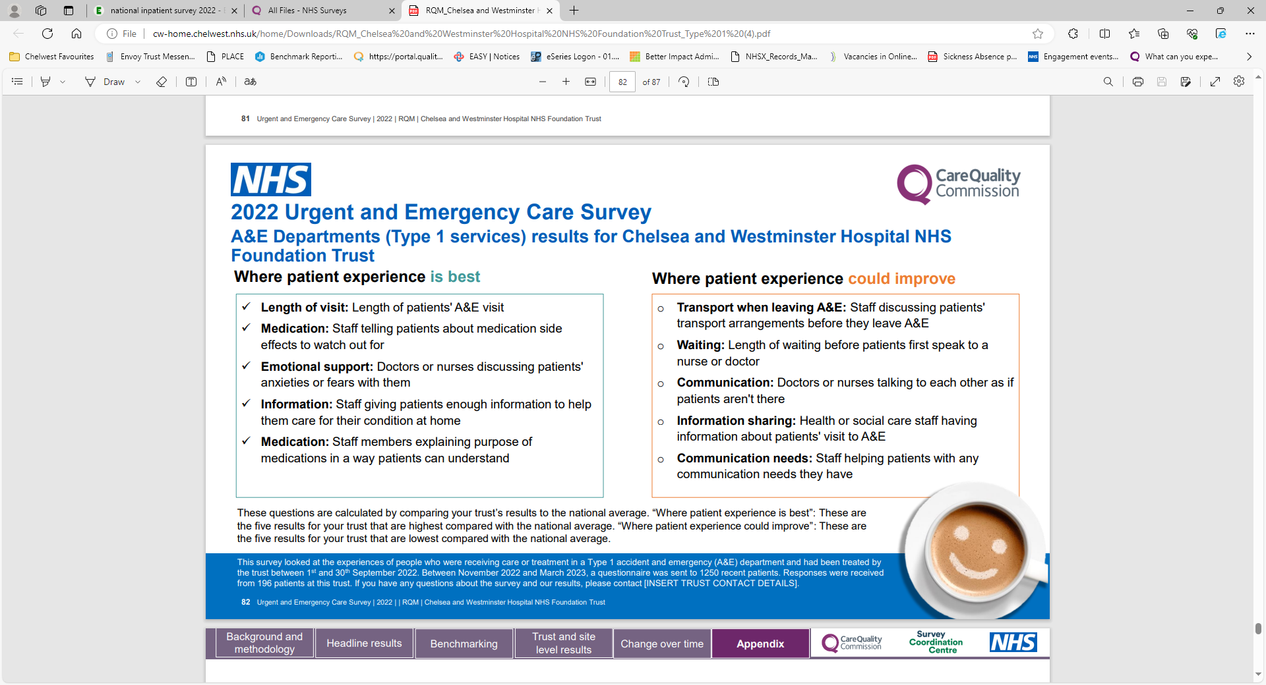

Figure 16 High level summary – Inpatient 2022 benchmarking report

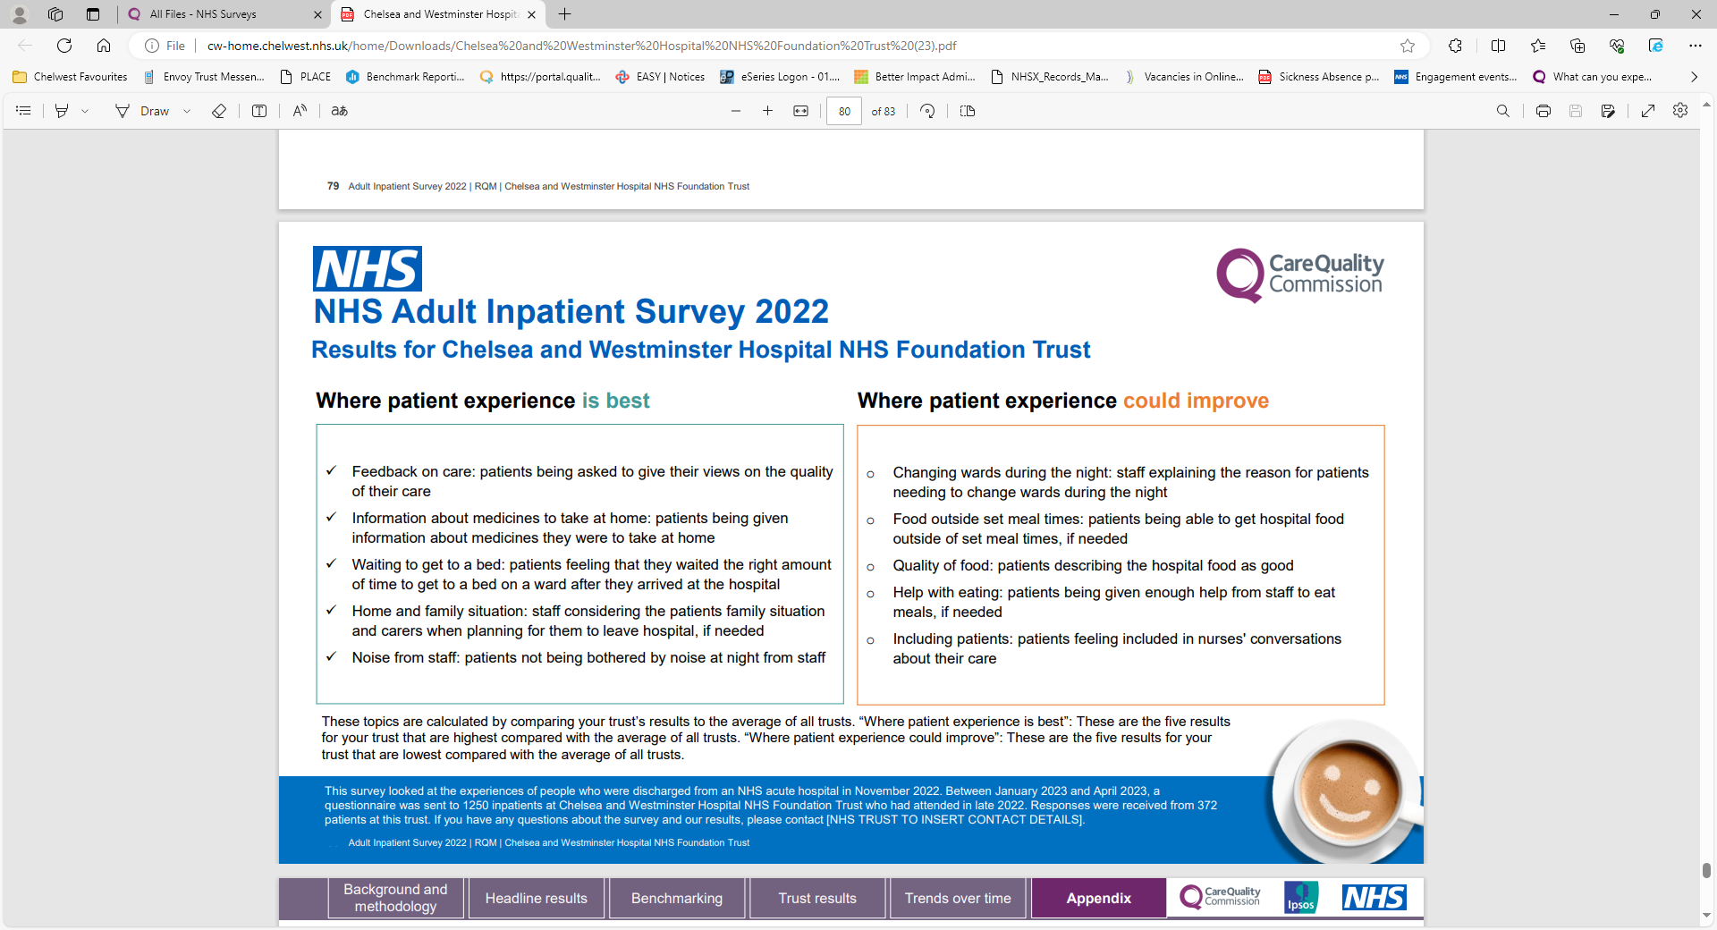

Figure 17 High level summary – Maternity 2023 benchmarking report

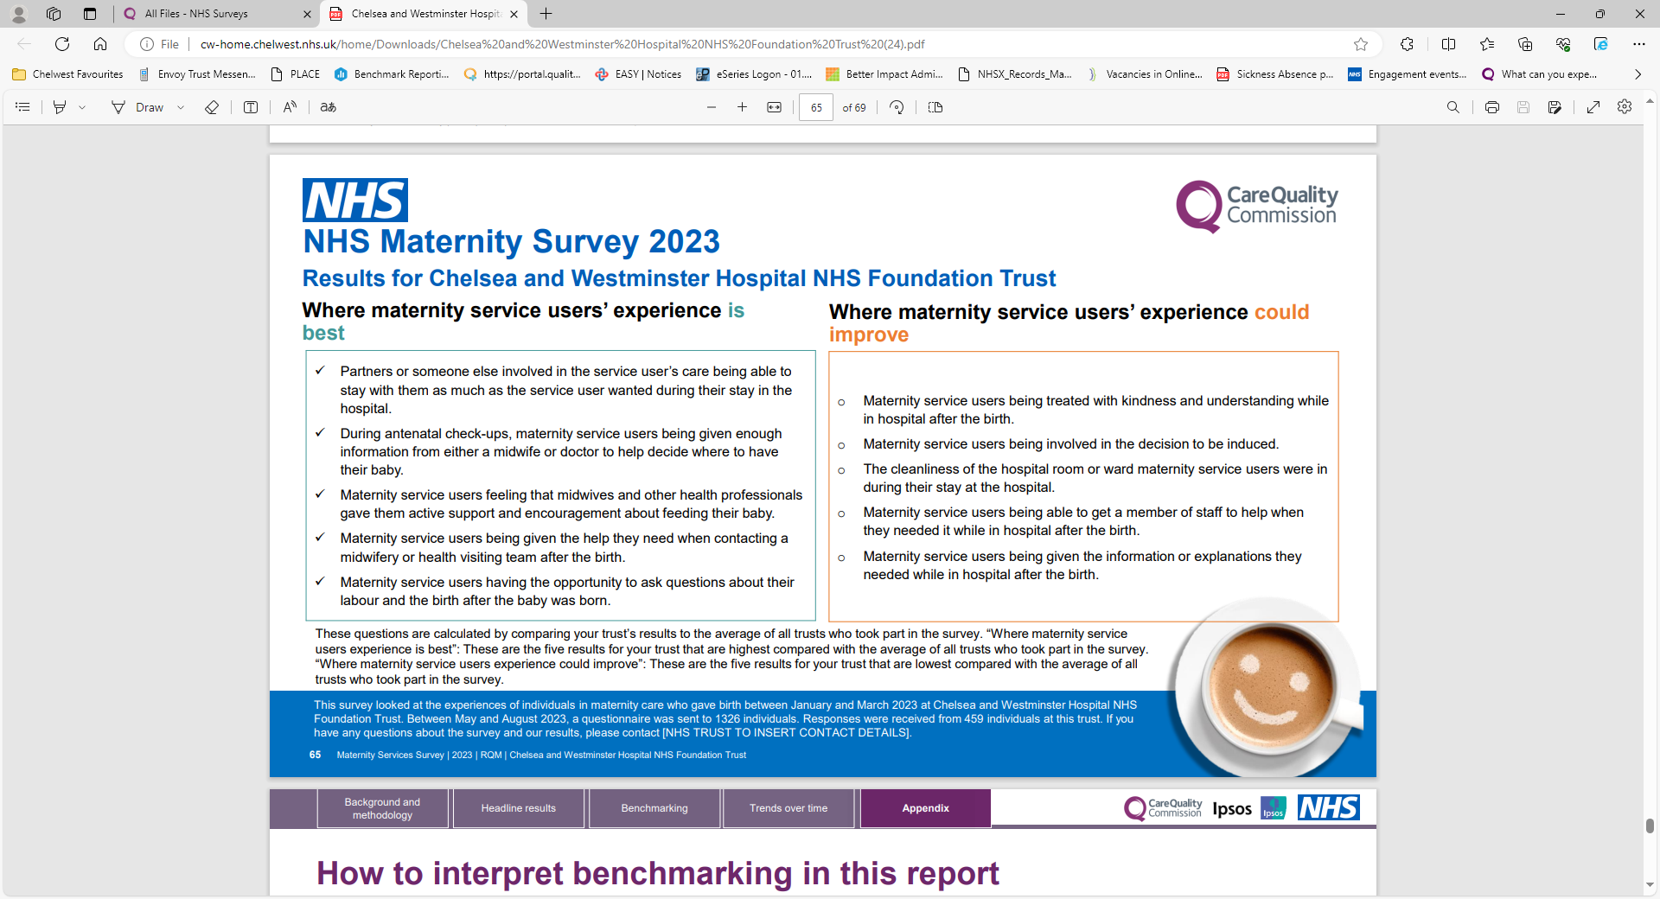

The patient experience team plays a pivotal role in divisions and services understanding the findings from the national surveys. Activities include:

* Full interrogation of trust level results including site comparisons
* Full interrogation and manual benchmarking with previous year’s results to see data trends and other benchmarking against London / NWL trusts
* Triangulation of other patient feedback data to support key areas of focus
* Drafting board reports
* Support with monitoring impact of the action plans

For the 2024-25 year, the following survey activities are being undertaken:

* UEC 2024 survey. Patients who attended A&E during January and February 2024 could be randomly selected to take part in the survey. It is expected that survey fieldwork will be undertaken between May – June, and results made available to trusts in August 2024
* Maternity 2024 survey. Women who gave birth in January and February 2024 could be randomly selected to take part in the survey. It is expected that survey fieldwork will be undertaken between May – June, and results made available to trusts in August 2024

As detailed in the FFT section of this report, a selection of questions from these national surveys will be included in FFT surveys going forward for the year 24-25, to allow for deeper patient experience insights and assurance that improvement work is effective.

There have been a number of improvements introduced following the national survey results and which have been referenced throughout this report. These include improvements to the waiting environment in our A&E departments, noise at night projects and improving access to entertainment on wards, extending antenatal appointments, review and revising the induction patient information and a kindness campaign with postnatal areas.

|  |  |  |
| --- | --- | --- |
| **Care Opinion** | Positive | Negative |
| **Access to treatment** | 50% | 50% |
| **Appointments** | 18% | 82% |
| **Clinical treatment** | 74% | 36% |
| **Communication** | 43% | 57% |
| **Privacy and dignity** | 0% | 100% |
| **Patient care** | 86% | 14% |
| **Staff attitude** | 81% | 19% |
| **Environment** | 100% | 0% |
| **Waiting times** | 37% | 63% |

|  |  |  |
| --- | --- | --- |
| **Google - CW** | Positive | Negative |
| **Access to treatment** | 87% | 13% |
| **Appointments** | 86% | 14% |
| **Clinical treatment** | 84% | 16% |
| **Communication** | 58% | 42% |
| **Privacy & Dignity** | 0% | 0% |
| **Patient care** | 67% | 33% |
| **Staff attitude** | 52% | 48% |
| **Waiting times** | 40% | 60% |
| **Environment** | 90% | 10% |

|  |  |  |
| --- | --- | --- |
| **Google - WM** | Positive | Negative |
| **Access to treatment** | 36% | 64% |
| **Appointments** | 25% | 75% |
| **Clinical treatment** | 68% | 32% |
| **Communication** | 12% | 88% |
| **Privacy and dignity** | 50% | 50% |
| **Patient care** | 60% | 40% |
| **Staff attitude** | 49% | 51% |
| **Environment** | 25% | 75% |
| **Waiting times** | 7% | 93% |

**14. Other Feedback**

* A total of 77 reviews have been left on CareOpinion over the 2023-24 period. 22% of the reviews relate to Chelsea and Westminster, 66% relate to West Middlesex Hospital. Feedback is seen across all four services – A&E, Maternity, Inpatients and Outpatients. Although a percentage of reviews are submitted without a specific site location. All feedback is responded to and patients/writers are given the opportunity to discuss their experience further with the Patient Experience team or PALS.
* 66 reviews were left for Chelsea on Google reviews platform.168 reviews were left on West Middlesex Google review platform over the last financial year. Challenges continue due to a fraction of the reviews lacking information, having one star ratings without any feedback. The table above shows continuous themes that mirror across other platforms.

**NOTICE:** In January 2024 NHSE made the decision to remove individual trust’s access to google accounts meaning we are no longer able to respond directly to people leaving feedback through google reviews. Despite these restrictions, the patient experience team continue to share any feedback with services where appropriate.

**15. Patient Involvement**

The Trust has a number of new and established patient forums and user groups. These groups play a pivotal role in providing more platforms for patient feedback and also support coproduction and collaboration on improvement initiatives. All of these forums report into the PPEEG. Examples of some of the Trust’s patient forums are outlined below:

- Life after Stroke (CW) – the group is chaired by the lead Stroke Consultant at the hospital site. The group meet quarterly and discuss ways to improve the hospital and post discharge journeys for stroke patients at Chelsea and Westminster Hospital.

- Surviving a Stroke (WM) – similar to the above, this group was formed to give the opportunity to give feedback on the hospital and post discharge journey for stroke patients at West Middlesex University hospital. The group is chaired by the lead nurse and has led to improvement initiatives such as improved support with eating on the ward, introduction of blood pressure monitoring devices for patients at home and collaborating with patients to review some of the staff training available in the unit, to ensure it is patient centred and focused.

- Maternity and Neonatal Voices Partnership (MNVP) – this is a long standing user group chaired by women who have previously accessed maternity care at the Trust. The group’s membership and structure was revised towards the end of the year to include neonatal voices. The group meets quarterly to discuss and reflect on feedback from women accessing maternity care, provide independent support to women going through the pathway and identify and endorse improvements. Outputs over the year include more dynamic and user engaging patient information such as the maternity anaesthesia animation, support with a project aimed at procuring new bedside COTs for women whilst they are on the ward and creating the cultural safety subgroup, to ensure the Trust are hearing from those seldom heard groups and ethnic minorities.

- Gender Affirmation Service – Transmasculine Patient Participation Group – this forum allows individuals from the trans and non-binary community to voice thoughts and opinions on how to deliver outstanding trans gender health care at the Trust. Attendees have been pivotal in co-developing patient information for the Chelsea Centre for Gender Surgery and acting as patient champions during staff training.

* Living with HIV – this group brings together patients and professionals of the Kobler Clinic each quarter to discuss health outcomes, general feedback and improvement initiatives. The group was newly formed towards the end of the year, but has already seen strong engagement from the patient population and outputs will be reported through the Trust’s PPEEG and the 2024-25 patient experience annual report.
* ENDO Voice – this is a well-established forum for patients accessing Endoscopy care at the Trust. The forum meets quarterly to share feedback on their experience and journey through the department, and what could be improved. Feedback from patients has been used to improve DNA and cancellation rates in the department, introduction of a new diet sheet, looking at introducing a digital board to keep patients updated on wait times and looking at how we better communicate with patients from ethnic minority groups.
* Intensive Care Unit (ICU) Patient Focus Group – the group invites previous ICU patients back into the hospital to share feedback on their experience and interact with the teams that cared for them. Some of the outputs from this recently restarted group; ongoing work on delirium management, ongoing work to support visitors and exploring how we can continue to support a positive step down from ICU onto the wards.
* Neonatal Parent Support Group – this is an informal group, facilitated by the unit psychologist to provide psychological and emotional support to parents of babies who are inpatient to the unit. Parents are assured of a confidential space, so feedback is not given to the multidisciplinary team about discussions that occur. For this forum, parents have indicated they would prefer it if a nurse or medical member of the team does not attend. Parents have reported this group helps them cope better during a difficult time, due to the support provided by the psychologist but also due to relationship building with other parents.

**16. Volunteering Service**

In June 2023, the volunteering team published their 3 year strategy for becoming a transformational service, which positively impacts the lives of our patients, staff and volunteers. This strategy has 4 aims:

**Strategic aim one -** We want to have a more positive impact on patients; reaching more patients, in more ways, in more areas of the hospital (and at home), at more times of the week.

**Strategic aim two -** We want to have a more positive impact on staff; saving more clinical and non-clinical staff time, and contributing to wellbeing, to help alleviate pressures staff.

**Strategic aim three -** We want to have a more positive impact on volunteers; empowering and engaging a more diverse range of people, including those from more challenged backgrounds, and acting as a catalyst for social mobility by helping them to reach their personal and professional goals.

**Strategic objective four -** We want to create a highly professional service; volunteers will be recruited and oriented quickly, partner volunteers will be deployed in line with Trust standards and coordinated jointly, and the service will strive to continue improving volunteer experience and retention.

A number of objectives and associated metrics make up each of these strategic aims. Despite not achieving some of the desired end of year metrics, there has been successful progress made against some of the strategic objectives for 2023-24 and 2024-25. Baseline data start points differ for some metrics as there was a staggered approach to collecting and extracting this information from various data points.

See below some of the key achievements for the 2023-24 year:

* The volunteers contributed a total of 36,889 hours, which is an increase of 12% compared to the previous year. This saw an increase from an average of 215 to 222 active volunteers in a month over the same time period. This increased activity is despite there being extended absence in the team throughout the year

Figure 1 – Total volunteer contribution (hours per month)

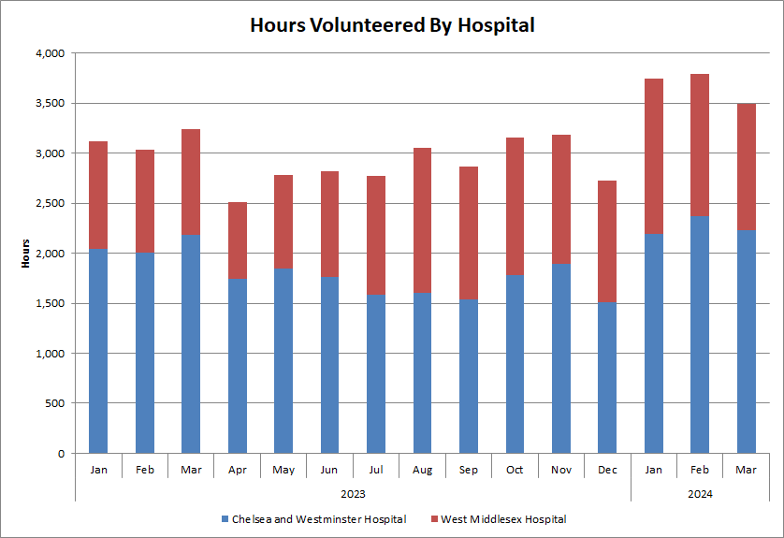

* There has been a 38% increase in clinical time saved and 55% increase in non-clinical time saved as a result of the volunteer offering when compared with the previous year.

Figure 2 – Approximate clinical time saved (hours)

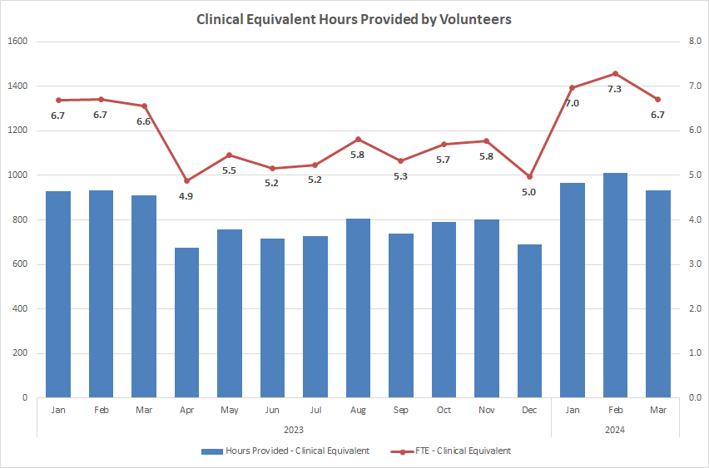

Figure 3 – Approximate non-clinical time saved (hours)

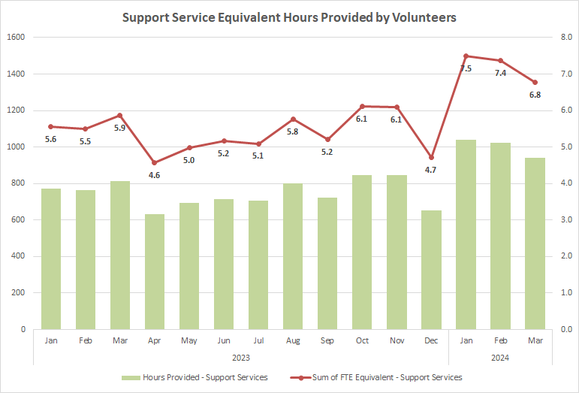

* The volunteering team saw a 16% reduction in the total number of volunteers departing after 3 months of inactivity – this went from 293 in 2022/23 to 246 in 2023/24.
* Despite external funding for the Butterfly volunteer programme ending in March 2023, the service has continued to evolve, integrate and expand. In 2023-24, a total of 185 patients were supported at West Middlesex site, which was an increase of 36 from the previous years and an accumulation of 446 hours. The service commenced at the Chelsea site and a total of 107 patients were supported, accumulating in 131 hours. The success of the service has resulted in external funding for a Butterfly Volunteer Manager from February 2024 to February 2025.
* The Open Minds pilot was externally funded and commenced in October 2023. Over the 6 month duration, the pilot had supported 10 volunteers, who have a range of neuro-diverse and complex needs, to contribute over 60 hours of volunteering each. 5 of these volunteers have since moved into full time employment both at the trust and externally.
* Achieved or on a positive trajectory for the team objectives focused on recruiting volunteers with a declared disability and those from ethnic minority backgrounds across both sites.
* Considerable collaboration and relationship building with community volunteering services and educational partners. For West Middlesex, this includes Richmond Volunteering services, Ealing & Hounslow Volunteering services, Brunel College, Richmond upon Thames College, Richmond Adult Hillcroft Community College, Reach Academy, Harrow Richmond and Uxbridge College, Roehampton University and Work Hounslow. At Chelsea, this includes City of Westminster College and South Thames Colleges Group. All collaborations have helped with successful placements for health and social care students or those who have an interest in future NHS careers.
* The Pets As Therapy volunteer offering continued to evolve and expand across both sites, with more therapists being on-boarded and positive feedback being received from patients and staff.
* Successfully on boarded, trained and supported more than 20 CW+ paid artists in Chelsea. This programme has evolved over the year and provided support to over 20,000 patients of patients across many different clinical areas. Further recruitment, on boarding and expansions of teams include MediCinema, CW+ Pets As Therapy, Chaplaincy at Chelsea and MacMillan volunteers.
* Continued bi-monthly volunteering newsletters for volunteers, partners and trust colleagues to create a sense of belonging within the volunteer community for the trust. Volunteers have stated this is informative and makes them feel a part of the team.
* Creation of a wellbeing volunteer role across both sites in response to requests from wards to offer companionships to patients who are admitted for prolonged periods of time. This role has already received positive feedback from patients and staff.

Despite the successes noted above, there have been a number of challenges or limited progress against some of the objectives and volunteering work streams. These have been outlined below:

* Historically the volunteering team have been reactive to the needs and demands of the trust, with a key component of this being the creation of ad-hoc volunteer roles and associated recruitment activities to fill posts; this continued into the 2023-24 year. Not all of these newly created roles have been successful or sustained over a long period; reasons for this include the ever changing needs and pressures of clinical services changing, and the subsequent impact this has on staff lead’s availability. This has meant significant volunteer time and resource could have been focused elsewhere, including key strategic objectives
* Some of the desired volunteer roles and support, outlined in the strategy, have not commenced due to other trust priorities requiring support. This includes the volunteer to career and youth pathways.
* There have been some extremely engaged areas who will provide a supportive and inclusive environment to volunteers that have been assigned there; however, there has been retention issues in areas where volunteers have not felt that sense of belonging or being given sufficient tasks to complete. As of 2024-25 year, the volunteering service is looking to move to a more clinically led and integrated model, which with the right support, direction and training, will hopefully give them a greater sense of belonging in departments but also gain greater buy in from clinical teams.

**17. Patient Information**

At the start of 2023-24 there was a total of 495 published on the external Trust website; of this 495, the trust had assurance that 30% (n-148) were accurate and contained up to date information. At the end of 23-24, 60% of leaflets were updated by services with support of the patient experience team. The 40% that were not reviewed or updated are no longer available to patients and public, due to the risk associated with inaccurate information.

**18. Local Surveys**

The patient experience continues to support services and division will their local survey programmes. Survey results and acton plans are governed at a local level and reported at the PPEEG.

**19. Other**

The Trust undertook the national Patient Led Assessments of the Care Environment (PLACE) in October and November 2023. There was strong representation from our patients and public, with over 15 patient assessors supporting with this programme across both hospital sites. Improvements were noted in food service in addition to the environment in which we care for those with dementia and disabilities.

Healthwatch Kensington & Chelsea and Healthwatch Hammersmith & Fulham hosted a stall in September 2023 to help engage with our patients (and their families) who access care at Chelsea and Westminster Hospital.

Healthwatch Kensington & Chelsea, Healthwatch Westminster and Healthwatch Hammersmith & Fulham are planning to undertake an Enter and View visit of the Chelsea and Westminster Hospital Outpatient areas in April 2024. This has been agreed following themes seen in their published quarterly patient experience reports.

Healthwatch Kensington & Chelsea and Healthwatch Westminster are planning to host monthly stalls at the Chelsea and Westminster Hospital site throughout the 2024-25 year.

The Trust will continue to engage with Healthwatch Richmond and Healthwatch Hounslow, to explore involvement opportunities and better ways to improve the experience of patients accessing care at West Middlesex University Hospital.

**Appendix 1 - Formal complaints and PALS concerns received April 2023-March 2024**

The Trust received 458 complaints during the year (compared with 481 the previous year) with 282 received on the Chelsea and Westminster site, 175 at West Middlesex site and one for community clinics.

*Formal complaints by month and year, April 2022 – March 2024*

Below is a graph showing the number of complaints received by site for the past three years:

Please see breakdown of complaints received by specialty and site during the year:

*Formal complaints received by site and top 10 specialties*

Maternity/Obstetrics received the most complaints at Chelsea and Westminster Hospital, followed by the Emergency Departments on each site and also Trauma and Orthopaedics.

*Complaints received by Division and top ten subjects*

Communication and Patient Care are again top themes of complaints received across all Divisions as demonstrated in the charts above and below.

*Complaints received by Division and top ten sub-subjects*

Below is a chart showing complaints received by theme during the past three years:

|  |  |  |  |
| --- | --- | --- | --- |
| **Complaint theme** | **Number received**  **2021/22** | **Number received**  **2022/23** | **Number received 2023/24** |
| Access to treatment or drugs | 15 | 12 | 9 |
| Admissions, discharges and transfers | 18 | 20 | 25 |
| Appointments | 10 | 25 | 18 |
| Clinical treatment (across all specialties) | 137 | 156 | 135 |
| Communication | 132 | 128 | 106 |
| Consent to treatment | 0 | 3 | 1 |
| End of life care | 1 | 4 | 3 |
| Patient care | 79 | 78 | 81 |
| Prescribing errors | 2 | 0 | 4 |
| Privacy, dignity and wellbeing | 5 | 6 | 6 |
| Trust administration | 4 | 2 | 3 |
| Values and behaviours | 40 | 38 | 55 |
| Waiting times | 1 | 3 | 7 |
| Other | 2 | 2 | 1 |

The table above show the number of complaints received this year by subject which has remained similar to previous years. There has been an increase of 45% in the numbers of complaints received about values and behaviours and an increase in complaints about waiting times.

The *Top 10 locations that received a complaint – April 2023 – March 2024*

The Maternity Assessment Suite at Chelsea and Westminster Hospital received the most complaints this year:

The chart above provides information about sub-themes. A recurring theme of complaints for the MAS are delays in treatment and failure to provide adequate care.

**Demographic data**

*Demographic information taken from Cerner*

**Complaints received per 1000 bed days:**

|  |  |  |  |  |  |  |  |  |  |  |  |  |
| --- | --- | --- | --- | --- | --- | --- | --- | --- | --- | --- | --- | --- |
| **Month:** | **Apr** | **May** | **Jun** | **Jul** | **Aug** | **Sep** | **Oct** | **Nov** | **Dec** | **Jan** | **Feb** | **Mar** |
| **Bed days:** | 24668 | 24473 | 23483 | 23458 | 23536 | 23387 | 22772 | 23381 | 25566 | 26393 | 25717 | 26915 |
| **Complaints:** | 29 | 51 | 42 | 45 | 53 | 39 | 37 | 43 | 26 | 21 | 38 | 34 |
| **Complaints rec'd per 1000 bed days:** | 1.2 | 2.1 | 1.8 | 1.9 | 2.3 | 1.7 | 1.6 | 1.8 | 1.0 | 0.8 | 1.5 | 1.3 |

Chart showing total team activity for the past two years:

|  |  |  |  |  |  |  |  |  |
| --- | --- | --- | --- | --- | --- | --- | --- | --- |
| **Division** | **De-escalated concerns and complaints 23/24** | **Complaints 2023/24** | **Concerns 2023/24** | **Divisional Total 2023/24** | **De-escalated concerns and complaints 2022/23** | **Complaints 2022/23** | **Concerns 2022/23** | **Divisional Total 2022/23** |
| Corporate/Enterprise | 43 | 23 | 21 | **87** | 34 | 12 | 15 | **61** |
| Emergency and Integrated Care | 850 | 130 | 245 | **1225** | 634 | 139 | 189 | **962** |
| Planned Care | 646 | 138 | 305 | **1089** | 590 | 132 | 379 | **1101** |
| Clinical Support Service | 1065 | 26 | 62 | **1153** | 792 | 30 | 145 | **967** |
| Specialist Care Division | 653 | 119 | 79 | **851** | 655 | 138 | 141 | **934** |
| West London Children’s Healthcare | 119 | 22 | 23 | **164** | (see above) | 30 | 52 | **82** |
| **TOTAL** | **3376** | **458** | **735** | **4569** | **2705** | **481** | **921** | **4107** |

**Complaints performance**

The target of acknowledging 95% of complaints within two working days was not met on three occasions:

The graph below shows the Trust’s performance with responding to complaints within 25 working days. The KPI of 95% of complaints being responded to within 25 working days has not been met this year, there have been delays in receiving outcomes from investigators and also further investigation required to answer complaints which exceeded the 25 day timeframe. Investigators have been trained on the process to support with minimising delays.

**Divisional performance with responding to complaints:**

|  |  |  |  |  |  |  |  |  |  |  |  |  |  |
| --- | --- | --- | --- | --- | --- | --- | --- | --- | --- | --- | --- | --- | --- |
|  | **APR** | **MAY** | **JUN** | **JUL** | **AUG** | **SEP** | **OCT** | **NOV** | **DEC** | **JAN** | **FEB** | **MAR** | **Annual %** |
| **EIC** | 76% | 86% | 100% | 90% | 71% | 100% | 75% | 60% | 69% | 90% | 92% | 78% | 82% |
| **PC** | 92% | 91% | 100% | 80% | 89% | 75% | 67% | 85% | 100% | 100% | 100% | 100% | 90% |
| **CSS** | 100% | 100% | 100% | 100% | 100% | 100% | 100% | 100% | 100% | 100% | 100% | 100% | 100% |
| **SCD** | 82% | 94% | 100% | 100% | 100% | 94% | 93% | 91% | 100% | 100% | 100% | 71% | 94% |
| **Corp/Ent** | 33% | 100% | 100% | 100% | 100% | 100% | 100% | 100% | 100% | 100% | 100% | 100% | 95% |
| **WLCH** | 100% | 100% | 100% | 100% | 100% | 100% | 100% | 100% | 100% | 100% | 100% | 100% | 100% |
| **Month KPI** | 84% | 93% | 100% | 90% | 89% | 91% | 84% | 83% | 88% | 97% | 95% | 85% | 25% |

**Divisional Performance – response rate by Division (by month complaint received)**

The graph below shows how the percentage of complaints received and de-escalated, providing faster resolution for patients:

**Complaints signed first time**

The quality of complaint responses signed first time by the CEO is monitored. On average over 60% of complaints are signed first time by the CEO office. This does not include responses where minor amendments were made and re-submitted.

**Outcomes**

416 of the 458 complaints received between April 2023 and March 2024 have been completed. 66% of these complaints were either fully or partially upheld, this terminology to describe the outcome of complaints where we provided an explanation and apology for a shortfall in care. This outcome is determined by the investigator and recorded in Datix:

**Reopened complaints**

7% of the completed complaints investigated during April 2023 – March 2024 across all Divisions were subsequently reopened:

|  |  |  |  |  |  |
| --- | --- | --- | --- | --- | --- |
| **Division** | **CSS** | **EIC** | **PC** | **Specialist Care** | **WLC/Corp/Ent** |
| Number completed | 25 | 113 | 128 | 105 | 40 |
| Number reopened | 2 | 3 | 11 | 8 | 4 |
| % reopened | **8%** | **3%** | **9%** | **8%** | **10%** |

**Parliamentary and Health Service Ombudsman (PHSO)**

**Please see the table below which provides information relating to PHSO investigations:**

|  |  |  |  |  |
| --- | --- | --- | --- | --- |
|  | **2019/20** | **2020/21** | **2021/22** | **2022/23** |
| Contacts from PHSO | Information  not available | 11 | 13 | 15 |
| Complaints taken on for investigation | 3 | 3 | 4 | 1 |
| Complaints fully or partially upheld | 1 | 5 | 2 | 1 |
| Complaints not upheld | 1 | 0 | 2 | 0 |

21 requests for files and records were made by the PHSO during April 2023 – March 2024. Six complaints were subsequently taken on for investigation. There are seven complaints currently open with the PHSO for investigation:

|  |  |  |  |  |  |
| --- | --- | --- | --- | --- | --- |
| **ID** | **Site** | **Division** | **Specialty** | **Final Response to complainant** | **PHSO commenced process** |
| 17674 | Chelsea and Westminster Hospital | Specialist Care | Maternity | 13.7.21 | 1.2.23 |
| 20471 | West Middlesex Hospital | Planned Care | General Surgery | 21.11.22 | 22.8.23 |
| 20443 | Chelsea and Westminster Hospital | Emergency and Integrated Care | Care of the Elderly | 2.3.23 | 21.11.23 |
| 19791 | West Middlesex Hospital | Planned Care | ICU | 4.4.23 | 10.1.24 |
| 19691 | Chelsea and Westminster Hospital | Emergency and Integrated Care | Care of the Elderly | 6.1.23 | 19.1.24 |
| 18362 | West Middlesex Hospital | Planned Care | Anaesthetics | 14.3.22 | 12.3.24 |
| 20997 | West Middlesex Hospital | Emergency and Integrated Care | Acute Medicine | 9.1.23 | 19.3.24 |

The PHSO did not conclude any investigations between April 2023 and March 2024.

**Actions and learning from complaints**

Examples of actions and learning from the most complained about subjects are reported to the Quality Committee each quarter, here are some examples:

|  |  |  |
| --- | --- | --- |
|  | **‘You said’** | **‘We did’** |
| ***Theme*** | ***Sub-themes*** | ***Actions taken to address complaints*** |
| **Communication** | * Patient admitted with chronic condition and co-morbidities on several occasions requiring oxygen and was not discharged with this despite requests from family. * Patient complained about their experience of induction of labour * Information that should be kept confidential was visible through an envelope. | * Review of patient’s diagnosis between different treating teams no - trigger to start Advanced Care Planning, resulting in siloed care. As a result improvements in MDT discussions have been taken forward with multiple providers. * Information provided to women on the induction of labour pathway reviewed. An online information session for women has been created to assist with provision of information. * Letters being sent out to be checked to ensure that only the recipient and their address is visual in the envelope window and the administration team have been updated on how to fold the letters correctly to prevent personal details being displayed in the future. |
| **Patient care** | * Patient found their bed space dirty and sheets not changed. * Patient complained about a lack of knowledge and support after surgery * Family have complained after about the ward care of a patient with fragile skin. | * Cleanliness and sheets to be changed regularly. Cleanliness audits stepped up. * The team on Richmond Ward have been provided with additional Stoma Care and education and training and have developed a surgical rotation to support nurses to advance their skills. * Nursing team to ensure body mapping is used to assess mother’s skin and document the bruises. |
| **Clinical care and treatment – Obs/Gynae** | * A patient's baby scans which had been tracked on another woman’s growth chart. * Woman had a procedure without her consent and not given any information about the procedure * A lack of breastfeeding assistance reported by a new mother. | * Antenatal Clinic Matron has asked midwives to be vigilant when filing papers into patient records. * A locum policy and local induction programme has been produced to ensure clear communication of the required standards and awareness of local guidance and expected practices around documentation, consent and communication are upheld. Orientation and local induction should also include agency nurses to make sure that they are aware of our local policies and particularly around chaperoning and advocacy for our patients. * All mothers and babies should be having breastfeeding assessments by their ward midwife. Infant feeding support is the responsibility of the midwife on the ward. In instances where there are feeding challenges identified by the ward midwives, a referral to the infant feeding team prior to discharge is recommended and the infant feeding team have reiterated this to the ward team. |

**Informal PALS concerns**

735 informal concerns were logged during this reporting period. 303 were for Chelsea and Westminster site and 432 were for West Middlesex site.

*Informal concerns by month and year, April 2022 to March 2024*

*Informal concerns by Specialty and site, April 2023 – March 2024*

In comparison to previous years, the majority of concerns were raised about both Emergency Departments, followed by ENT at West Middlesex Hospital. Patients contacted us with problems with appointments and poor communication in this area.

The majority of concerns raised were about communication followed by appointments. There are highlighted issues with appointments and capacity in Planned Care.

*Top 10 concerns raised by Division and subject*

**Informal concerns: Trust performance**

The PALS and Complaints team strives to respond to concerns either instantly or within the five-day timeframe in order to try and obtain instant resolution for our patients. The team were meeting or exceeding the KPI of 90% every month, however changes in staffing within the PALs and Complaints team and delays in producing outcomes from divisional colleagues during Q3 and Q4 have meant that compliance was not met. The team are now fully staffed and it is expected that compliance will be met from April onwards.

*Trust wide informal concerns performance*

The graph below shows how many concerns were received and responded to immediately.

**Compliments**

437 compliments were logged by the PALS team from a patient or their family/representative within Datix during 2023/24 and a breakdown by Division is shown below:

*Fig 8: Compliments by Division and month, April 2023-March 2024*